**VNM SHIFTER USER MANUAL**

Contents

**1. RUN Mode/DFU mode** 2

**2.** **H-pattern/Sequential working mode** 2

**3. Connection** 3

**4. Configuration Shifter UI** 3

**4.1. Download VNM Configurator** 3

**4.2. VNM Configuration overview** 5

**4.3. Led Configuration** 6

**4.4. Shifter Calibration** 7

**4.4.1. H-pattern Calibration** 7

**4.4.2 H-pattern threshold setup** 7

**4.4.3. Calibrate sequential** 8

**4.4.4 Sequential threshold setup** 9

**5. Firmware Update** 9

# **1. RUN Mode/DFU mode**

VNM Shifter has 2 modes:

* RUN mode: it acts as hid device to simulate a shifter.
* DFU mode: it acts as DFU device to upgrade firmware

There is a switch or a button at the back of shifter to change mode between RUN or DFU mode. After change state of button or switch position, you must reconnect the shifter cable:

* The button is in low state 🡺 the shifter is in RUN mode. The button is in high state 🡺 the shifter is in DFU mode

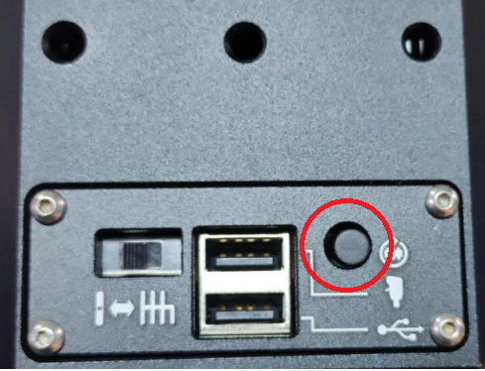

* The switch: The switch is at RUN position 🡺 the shifter is in RUN mode. The switch is at DFU position 🡺 the shifter is in DFU mode.

# **H-pattern/Sequential working mode**

The shifter has both h-pattern and sequential working mode. Exchange working mode by changing a switch’s position at the back of shifter.

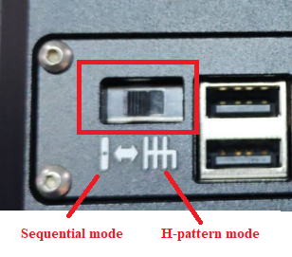

# **3. Connection**

* Connect shifter to PC via lower USB Port.

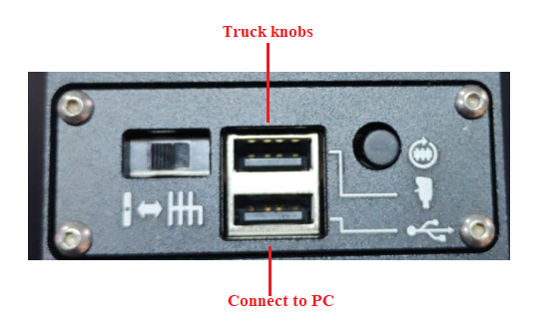

* The Upper port is used to connect truck knob

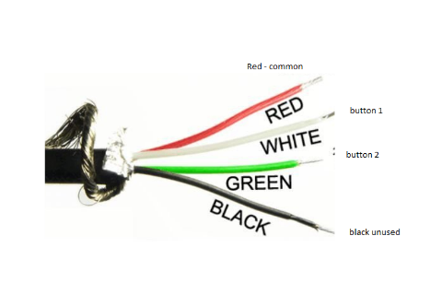

# **4. Configuration Shifter UI**

## **4.1. Download VNM Configurator**

VNM Configuration software is used to configure VNM Shifter. Pls download from [here](https://github.com/hoantv/VNM_CONFIGURATOR_UI_RELEASE).

Click Code -> download ZIP

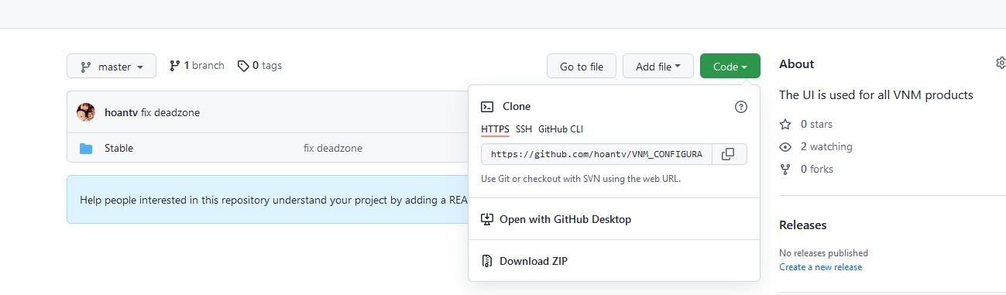

Extract the downloaded ZIP, go to stable 🡺 3.x (or latest if have). Extract VNMWheelConfig.rar and open VNMWheelConfig.exe



If your computer doesn’t allow open it, click left mouse to VNMWheelConfig.exe 🡪 click right mouse 🡪 click left mouse to properties

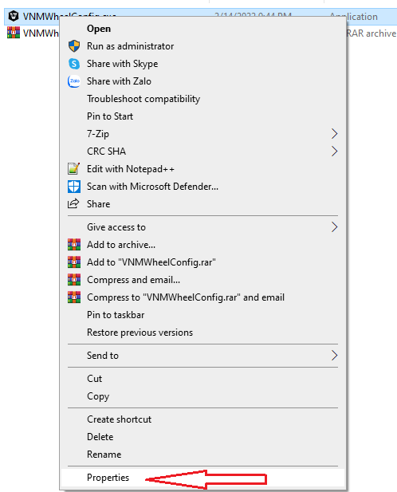

Click Unlock button and reopen VNMWheelConfig.exe again.

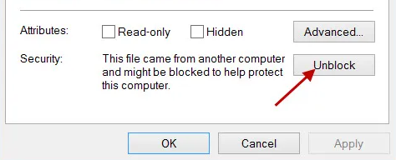

## **4.2. VNM Configuration overview**

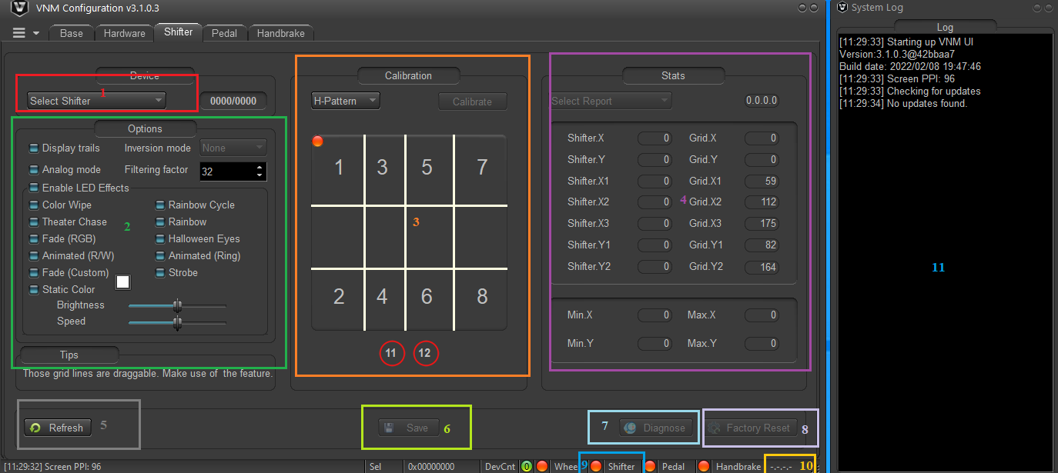

1. Select shifter: Choose the shifter that you want to connect (beside VNM Shifter, VNM Wheelbase, VNM Direct drive support shifter feature too).

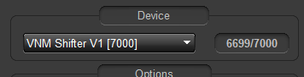

2. Option area: You can configure the led color, enable/disable led and some internal parameter of shifter (internal of shifter must not be change unless a recommendation from the manufacturer or distributor).

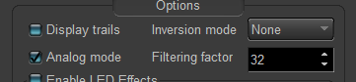

3. The grid is for calibration and gear threshold setup.

4. Stat area shows internal parameter when calibrating.

5. Refresh button to get current parameter of the shifter.

6. Save button sends and persists the setting to shifter.

7. Diagnose button is used to troubleshoot communication between the shifter and VNM Configuration

8. Factory Reset button resets all setting to default setting.

9. Shifter status dot will be green when the shifter is in RUN mode and connect to PC, will be orange if the shifter is DFU mode or not connected.

10. This area shows current firmware of the shifter.

11. The log window log the communication of shifter and VNM Configuration.

## **4.3. Led Configuration**

* Check/uncheck “Enable LED Effects” checkbox to enable /disable LED

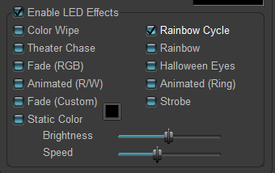

* You need at least one effect when you enable the led (if static color is chosen, it only displays static color).
* You can change the brightness and speed of effects by adjusting the Brightness and Speed bar.
* Fade (custom): click to square button (1), a pop-up is display. You can choose available colors in (2). To add new color by click to edit button (3). In (4) you can click anywhere to choose a color that you like and click add to add new color to the list more options. After choosing a color, click OK button on popup.
* Click Save button after you configured led effects

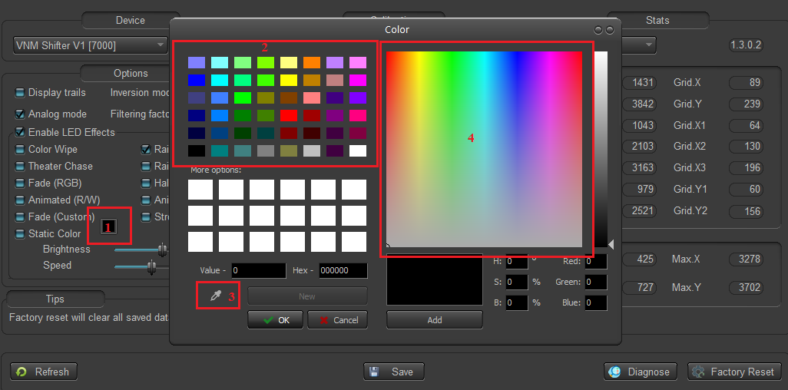

## **4.4. Shifter Calibration**

It is uses to find the min-max value of X, Y axis. Only use at the 1st time uploading firmware or click factory reset button.

Note: Must calibration for each mode.

### **4.4.1. H-pattern Calibration**

* Step 1: put h-pattern plate onto the shifter and change the working switch
* Step 2: click “calibrate” button, it will turn into “finish”, an instruction popup is display, click “ok” button.
* Step 3: Switch the shifter to the top-most, bottom-most, left-most, right-most. Do it several times.
* Step 4: Click “finish” when you’ve done.
* Step 5: click save to persist calibrate information to ROM

### **4.4.2 H-pattern threshold setup**

* Step 1: Put the h-pattern plate to the shifter, switch to h-pattern mode.
* Step 2: On select report combo box, choose Shifter configuration.
* Step 3: click “display trails” to show the road of shifter’s position.
* Step 4: move the shifter to each position. The trail display on the grid like this

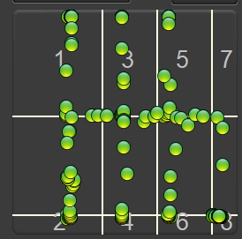

* Step 5: Drag/drop the vertical white lines such that when the shifter at a position, The green pot doesn’t That point does not overlap white lines.

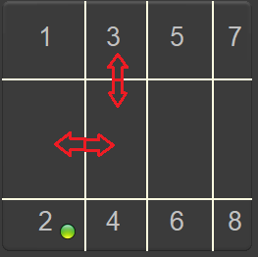

* Step 6: Click save
* Step 7: test again to make sure all gear position work.

### **4.4.3. Calibrate sequential**

It is uses to find the min-max value of Y axis. Only use at the 1st time uploading firmware or click factory reset button.

* Step 1: put the sequential plate onto the shifter.
* Step 2: click “calibrate” button, it will turn into “finish”, a instruction popup is display, click “ok” button.
* Step 3: Switch the shifter to the top-most, bottom-most. Do it several times.
* Step 4: Click “finish” when you’ve done.
* Step 5: click save to persist calibrate information to ROM

### **4.4.4 Sequential threshold setup**

* Step 1: Put the sequential plate to the shifter, switch to sequential mode
* Step 2: do like h-pattern setting with only 2 horizontal white lines
* Step 3: Click save
* Step 4: test again to make sure all gear position work.

# **5. Firmware Update**

* Download latest firmware from [here](https://github.com/hoantv/VNM_SHIFTER_V1_RELEASE)
* Download update tool from [here](https://github.com/hoantv/VNM_UPDATE_TOOL)
* How to upgrade: please read “INSTALL VNM FLASH AND CONFIG DRIVER DFU” document in folder update tool above.

If you have any question, please contact with the distributor or email to sale@vnmsilumation.com